# HW3_pronlem1

Code:

Properties {  
 _BaseTex ("Base (RGB) diffuse", 2D) = "white" {}  
 _BaseTex2 ("Base (RGB) Gloss (A)", 2D) = "white" {}  
 _Cube ("Reflection Cubemap", CUBE) = "white" {}  
  
}

sampler2D _BaseTex;  
 float4 _BaseTex_ST;  
  
sampler2D _BaseTex2;  
float4 _BaseTex2_ST;

struct v2f { // vertex to fragment  
 float4 sv: SV_POSITION;   
 float2 uv:TEXCOORD0;  
 float2 uv2:TEXCOORD1;  
 float3 positionWS: TEXCOORD2;   
 float3 normalWS: TEXCOORD3;  
  
};

output.normalWS = normalize(mul(input.normalOS, (float3x3) unity_WorldToObject));  
output.uv = TRANSFORM_TEX(input.uv, _BaseTex);  
output.uv2 = TRANSFORM_TEX(input.uv, _BaseTex2);  
return output;

float4 FragEnvMapperPixel(v2f input) : COLOR {  
 // incident is opposite the direction of eyeDir in our other programs  
float3 incidentWS = normalize(input.positionWS - _WorldSpaceCameraPos.xyz);  
float3 reflectWS = reflect(incidentWS, input.normalWS);

float4 reflectColor = texCUBE(_Cube, reflectWS);  
float4 base = tex2D(_BaseTex, input.uv);  
float4 base2 = tex2D(_BaseTex2, input.uv2);

return(lerp(base, reflectColor, base2.a));

}

Demo:

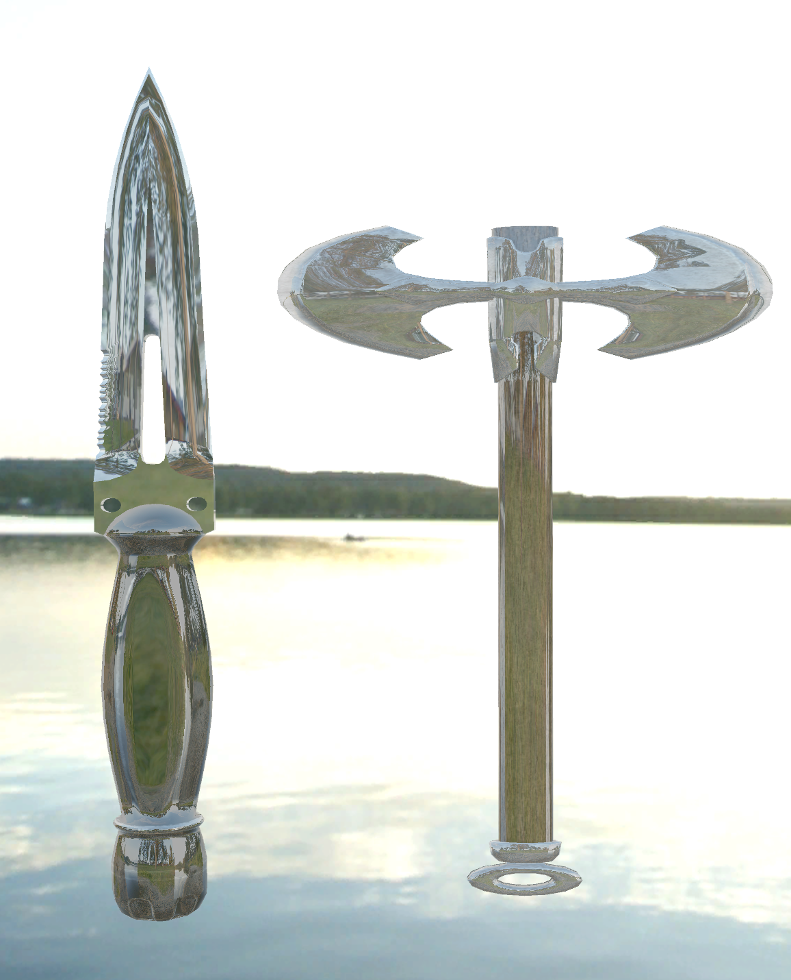

As we can see they all have the glossy look on them which is refectiing the cube map.

# HW3_problem2

Code:

Properties {  
 _Cube ("Reflection Cubemap", CUBE) = "white" {}  
 _Alpha ("Alpha", Range(0,1)) = 0.5  
 _etaRatioRed ("Eta Ratio Red", Range(0.01,3)) = 1.5  
 _etaRatioGreen ("Eta Ratio Green", Range(0.01,3)) = 1.5  
 _etaRatioBlue ("Eta Ratio Blue", Range(0.01,3)) = 1.5  
 _crossfade ("Crossfade", Range(0,1)) = 0  
 _fresnelBias ("Fresnel Bias", Range(0,1)) = 0.5  
 _fresnelScale ("Fresnel Scale", Range(0,1)) = 0.5  
 _fresnelPower ("Fresnel Power", Range(0,10)) = 0.5  
 [Toggle(BLUE_YELLOW)] _BlueYellow ("Blue Yellow", Float) = 0  
 [KeywordEnum(Crossfade, Fresnel)] _Blend ("Blend Mode", Float) = 0  
}

samplerCUBE _Cube;  
float _etaRatioRed;  
float _etaRatioBlue;  
float _etaRatioGreen;  
float _crossfade;  
float _fresnelBias;  
float _fresnelScale;  
float _fresnelPower;  
float _Alpha;

float4 FragEnvMapperPixel(v2f input) : COLOR {  
 // incident is opposite the direction of eyeDir in our other programs

float4 refractColor;  
float3 incidentWS = normalize(input.positionWS - _WorldSpaceCameraPos.xyz);  
float3 reflectWS = reflect(incidentWS, input.normalWS);  
float3 refractWSRed = refract(incidentWS, input.normalWS, _etaRatioRed);  
float3 refractWSGreen = refract(incidentWS, input.normalWS, _etaRatioGreen);  
float3 refractWSBlue = refract(incidentWS, input.normalWS, _etaRatioBlue);  
float4 reflectColor = texCUBE(_Cube, reflectWS);  
  
refractColor.r = texCUBE(_Cube, refractWSRed).r;  
refractColor.g = texCUBE(_Cube, refractWSGreen).g;  
refractColor.b = texCUBE(_Cube, refractWSBlue).b;  
refractColor.a = _Alpha;  
float reflectFactor = saturate(_fresnelBias +fresnelScale * pow(1 + dot(incidentWS, input.normalWS),_fresnelPower));  
  
#ifdef BLUE_YELLOW // for visualization  
refractColor = float4(1,1,0,1);  
reflectColor = float4(0,0,1,1);  
#endif  
  
#if defined(_BLEND_CROSSFADE)  
return(lerp(reflectColor, refractColor, _crossfade));  
#elif defined( _BLEND_FRESNEL)  
return(lerp(refractColor, reflectColor, reflectFactor));  
#endif  
 }

Demo

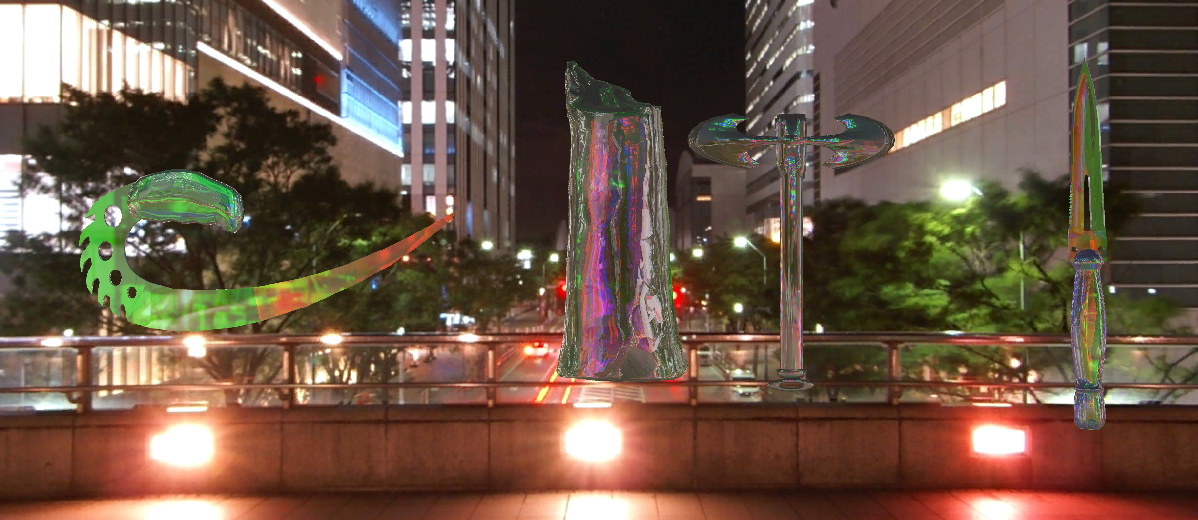

# HW3_problem3:

Code;

Properties {  
 _BaseTex ("Base (RGB) Gloss (A)", 2D) = "white" {}  
 _ProjTex ("Projected (RGB)", 2D) = "white" {}  
 _NormalMap("Normalmap", 2D) = "bump" {}  
 _SpotPower ("Spotlightiness", Range(0.01,1)) = 0.7  
}

sampler2D _BaseTex;   
float4 _BaseTex_ST;  
sampler2D _ProjTex;  
  
sampler2D _NormalMap;  
float4 _NormalMap_ST;  
   
float _SpotPower;  
  
float4x4 _myProjectorMatrixVP;  
float3 _spotlightDir;  
  
float4 _LightColor0;

struct a2v {   
float4 positionOS: POSITION;  
float3 normalOS: NORMAL;  
float4 tangentOS: TANGENT;  
float2 uv: TEXCOORD0;   
};  
   
struct v2f {   
float4 sv: SV_POSITION;  
float2 bmap_uv:TEXCOORD0;  
float2 nmap_uv: TEXCOORD1;

float3 positionWS: TEXCOORD2;   
float3 normalWS: TEXCOORD3;

float4 positionProjected: TEXCOORD4;  
float3 tangentWS: TEXCOORD5;  
float3 bitangentWS: TEXCOORD6;  
  
};

output.bmap_uv = TRANSFORM_TEX(input.uv, _BaseTex);  
output.nmap_uv = TRANSFORM_TEX(input.uv, _NormalMap);  
return output;

float4 FragProjectTexture(v2f input) : COLOR {  
float2 nMapXY = 2 * tex2D(_NormalMap, input.nmap_uv).ag - 1;  
float nMapRecreatedZ = sqrt(1 - saturate(dot(nMapXY,nMapXY)));  
  
// we are renormalizing because the GPU's interpolator doesn't know these are unit vectors  
float3 nWS = normalize(input.normalWS);  
float3 tWS = normalize(input.tangentWS);  
float3 btWS = normalize(input.bitangentWS);  
  
float3 newNormal = tWS * nMapXY.x + btWS * nMapXY.y + nWS * nMapRecreatedZ;  
newNormal = normalize(newNormal);  
  
// Unity light position convention is:  
// w = 0, directional light, with x y z pointing in opposite of light direction   
// w = 1, point light, with x y z indicating position coordinates  
  
  
  
 // Only use this shader with a point light  
float3 lightDir = normalize(_WorldSpaceLightPos0.xyz - input.positionWS * _WorldSpaceLightPos0.w);  
 // Renormalizing because the GPU's interpolator doesn't know this is a unit vector  
  
float3 diffAlmost = _LightColor0.rgb * max(0, dot(newNormal, lightDir));  
float spotlightEffect = pow(dot(normalize(_spotlightDir), -lightDir),_SpotPower * 128.0);  
diffAlmost *= spotlightEffect;  
diffAlmost *= tex2Dproj(_ProjTex,input.positionProjected);  
  
float4 base = tex2D(_BaseTex, input.bmap_uv);  
float3 output = diffAlmost * base.rgb;

return(float4(output,1));

}

Demo:  
